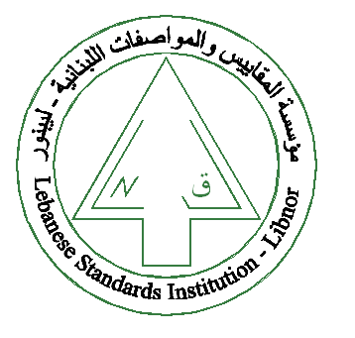
The Lebanese Standards Institution
Invites you to attend the
“Supply Chain Management”
Training course
Offered by LIBNOR training centre
Date: 22-23 March 2018 Time: 9:00am -4:00pm
Kindly contact us to register nominated candidates from your company,
Sincerely,

